4. What is scaling? Why is scaling performed? What is the difference between normalized scaling and standardized scaling?

ANSWER -->
Scaling: Also known as feature scaling, is Transformation of numerical data so that if fits within a specific scale/range, i.e. -100 to 100, or 0 to 1.

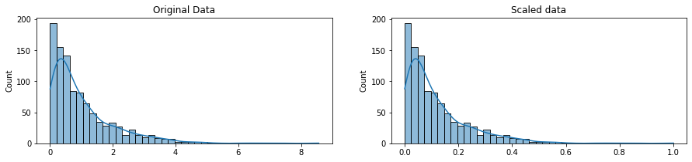
Importance of Scaling
Numerical Data in a dataset are generally very far from each other, thus algorithms will take more time to understand the data resulting in low accuracy.
Hence, data values are brought closed to read other so that we can create properly train our models.

Normalized Scaling
- Values are distributed between minimum and maximum values so that they scale from 0 to 1.
- Minimum value is now 0.
- Maximum value is now 1.
- Useful for data following normal/gaussian distribution.
- Formulae for a (i) element in column(x):
        - (x_{i –} min(x))/(max(x)-min(x)
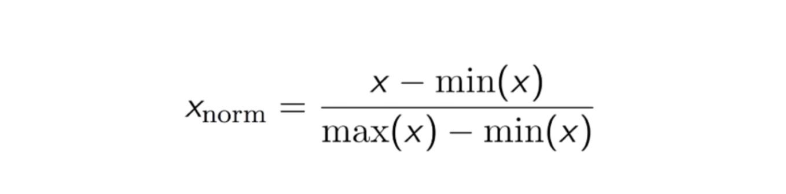

Standardized Scaling
- Values are distributed around mean, as units of standard deviation away.
- Mean value is now 0.
- Values greater than mean are positive deviation away while values less than mean are negative deviation away.
- Can handle outliers also.
- Formulae for a (i) element in column(x):
        - (x_{i –} mean(x))/standard_deviation(x)
